INFORMATION FOR THE MAIN CONFERENCE VENUE: HOTEL ARKA

GENERAL INFORMATION
The main venue for PTPI EU Conference 2020 in Skopje, North Macedonia will be Hotel Arka. Hotel Arka is a 5 star hotel located centrally at the Skopje Old Bazaar and near the main central location. There is a negotiated price for this hotel that will be valid only until June 01-st, 2020 the latest. Guests are recommended to make their reservations as soon as possible as the awarding of rooms will go on a first come- first served procedure.
The reservation of rooms will be open from December 15-th, 2019.
Please visit www.hotelarka.mk for more information.
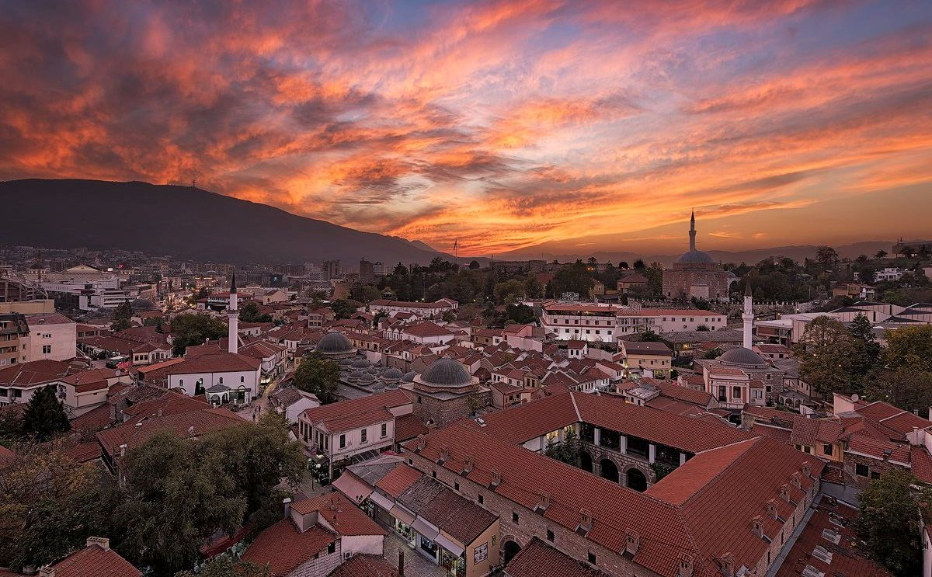
The view from Hotel Arka (Skopje Old Bazaar)

ROOMS AND PRICES
Hotel Arka offers wide range of rooms. Most of them are at 50 Euro per night price for one person and 65 Euro per night for two people, but there are some exceptions. The rooms are wide and spacious.
You can check images from the rooms at https://www.hotelarka.mk/rooms/rooms_and_suites-7333-120.
Bellow is a table with prices of each room in Hotel Arka. These prices are negotiated by PTPI Skopje and will only be valid until June-01 st, 2020. After this date, the rooms will be given on a regular price. The reservation of rooms and their availability comes on a first come- first serve approach.
Type of room | Type of bed | One person in a room (price/per night) | Two people in a room (price/per night) | Three people in a room (price/per night) | Number of rooms in the hotel
Standard | Queen Size Bed | 50 € | 65 € | / | 8
Standard Executive | Queen Size Bed | 50 € | 65 € | / | 6
De Lux | 2 Single Beds | 50 € | 65 € | / | 13
Club | King Size Bed | 50 € | 65 € | / | 2
Club | 2 Single Beds | 50 € | 65 € | 75 € | 4
Superior | Queen Size Bed | 50 € | 65 € | / | 2
Junior Suite | King Size Bed + 1 Sofa Bed | 50 € | 65 € | 75 € | 2
Pure White Suite | King Size Bed | 111 € | 111 € | / | 1
Wenge Suite | King Size Bed | 119 € | 119 € | / | 1
Black & White Suite | Queen Size Bed | 127 | 127 | / | 1

HOTEL SERVICES
All indicated prices include breakfast with them. The hotel offers the usage of sauna, fitness and WI-FI network free of charge for all guests. The hotel does NOT offer swimming pool services.
HOTEL LOCATION
Hotel Arka is situated in Skopje City Center at the Skopje Old Bazaar. Most of the major sights are walking distance from the hotel within 15-30-minute walk.
MAKING A RESERVATION
In order to make a reservation you need to send an email to the hotel manager Ana Domazetovska at the email address adomazetovska@hotelarka.mk. Please in this email put the following email address in cc: -ptpieuconference2020@gmail.com.
When you make the reservation, do not forget to use the reservation code: PTPI EU CONFERENCE 2020. You can mention the reservation code both in the subject of your email and within the email content.
In your email you should include the following information:
- Reservation Code: PTPI EU CONFERENCE 2020
- Type of room you reserve (example: Standard Executive):
- Number of people staying at the room:
- Arrival date and time:
- Departure date and time:
You will receive a confirmation email from the hotel with the total price for your stay.
PAYMENT
The guests pay 100% at the hotel reception on the day of their arrival. Payment can be made in local currency (MKD Denar) or Euro.
CANCELATION POLICY
Cancelation can be completed only in written form at the email adomazetovska@hotelarka.mk. Cancelation can be completed the latest one day (24 hours) before arrival. If the reservation is not cancelled under the stated conditions or if there is a no-show by the guest, the guest will need to pay a penalty of the price of one night per person to the hotel.

